LAB Logbook - 2512564

Lab 1
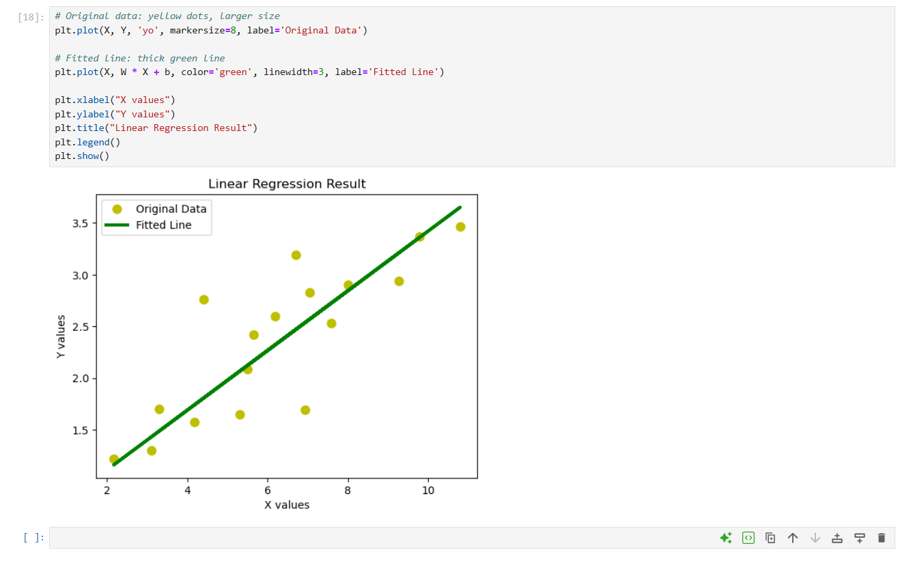

Lab 2
Accuracy = 0.900
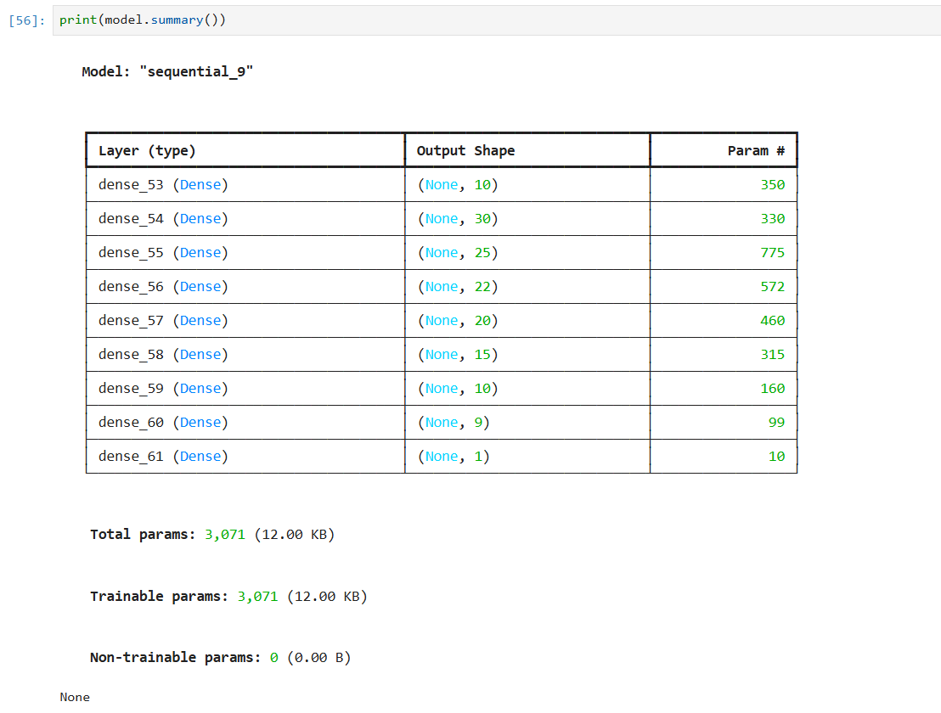

PART – 2:
SID = 2512564
O1 = 1.569
O2 = 1.569

Lab 3
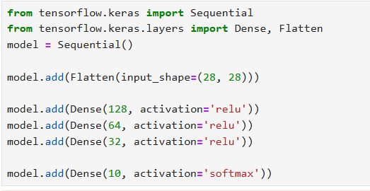

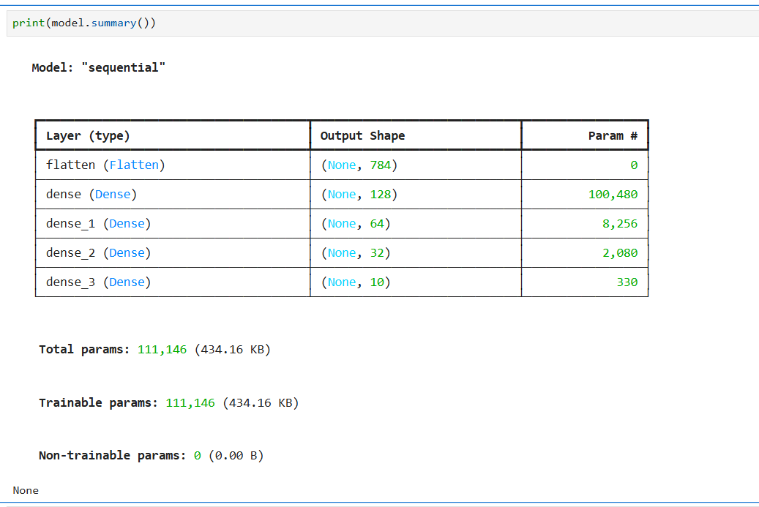

Test accuracy: 0.8916000127792358

